

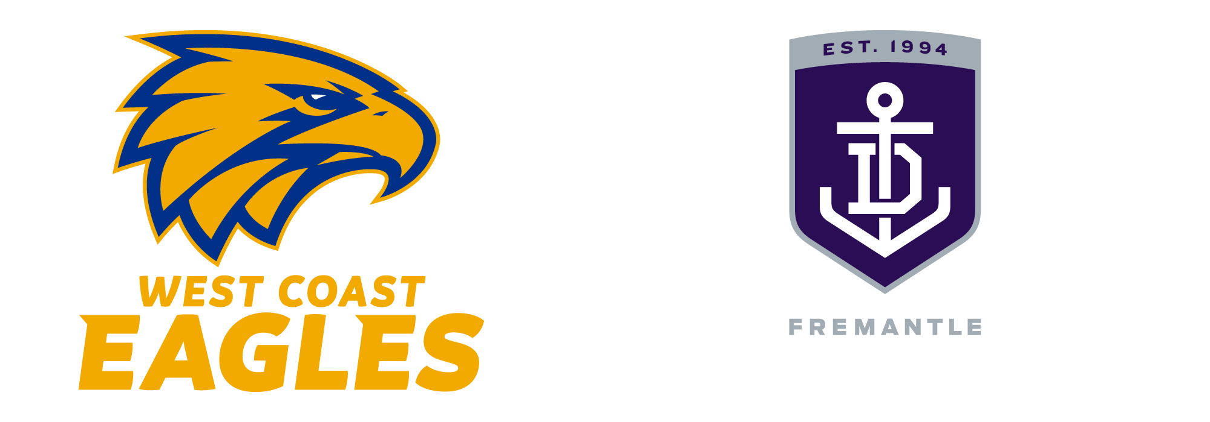

[Company names]
is pleased to invite
[Guest name here]
To watch the West Coast Eagles, play the Fremantle Dockers at Optus Stadium in
[select Premium facility here]
Bouncedown at 3.10pm on Sunday, April 19, 2026.
Further details, including ticketing, facility opening time and dress standards
will be provided on acceptance of this invitation.

Please RSVP to [Host name here] on [insert Host #] or [insert Host email]
(08) 9388 4521 | premium@wce.com.au | eagleshospitality.com.au

